English Level 3 Study Plan
(High B1 / B2 → High B2 / Low C1)
Date: 04/06/2026
Teacher: Anujin Baatartsogt

Level of students in two groups (Anu’s Dolphins and Octopus):
Intermediate: 58.3%
Pre-Intermediate: 33.3%
Elementary: 8.3%

The Challenge:
Students with mixed levels of Elementary (A1 ~ A2) and Pre-Intermediate/Intermediate (B1/B2) in English Level 3.

Proposed Action:
Keep Intermediate and Pre-Intermediate in my groups because the required English level is 3.
Guide elementary level or below pre-intermediate level students to Level 2 (A1 ~ A2).

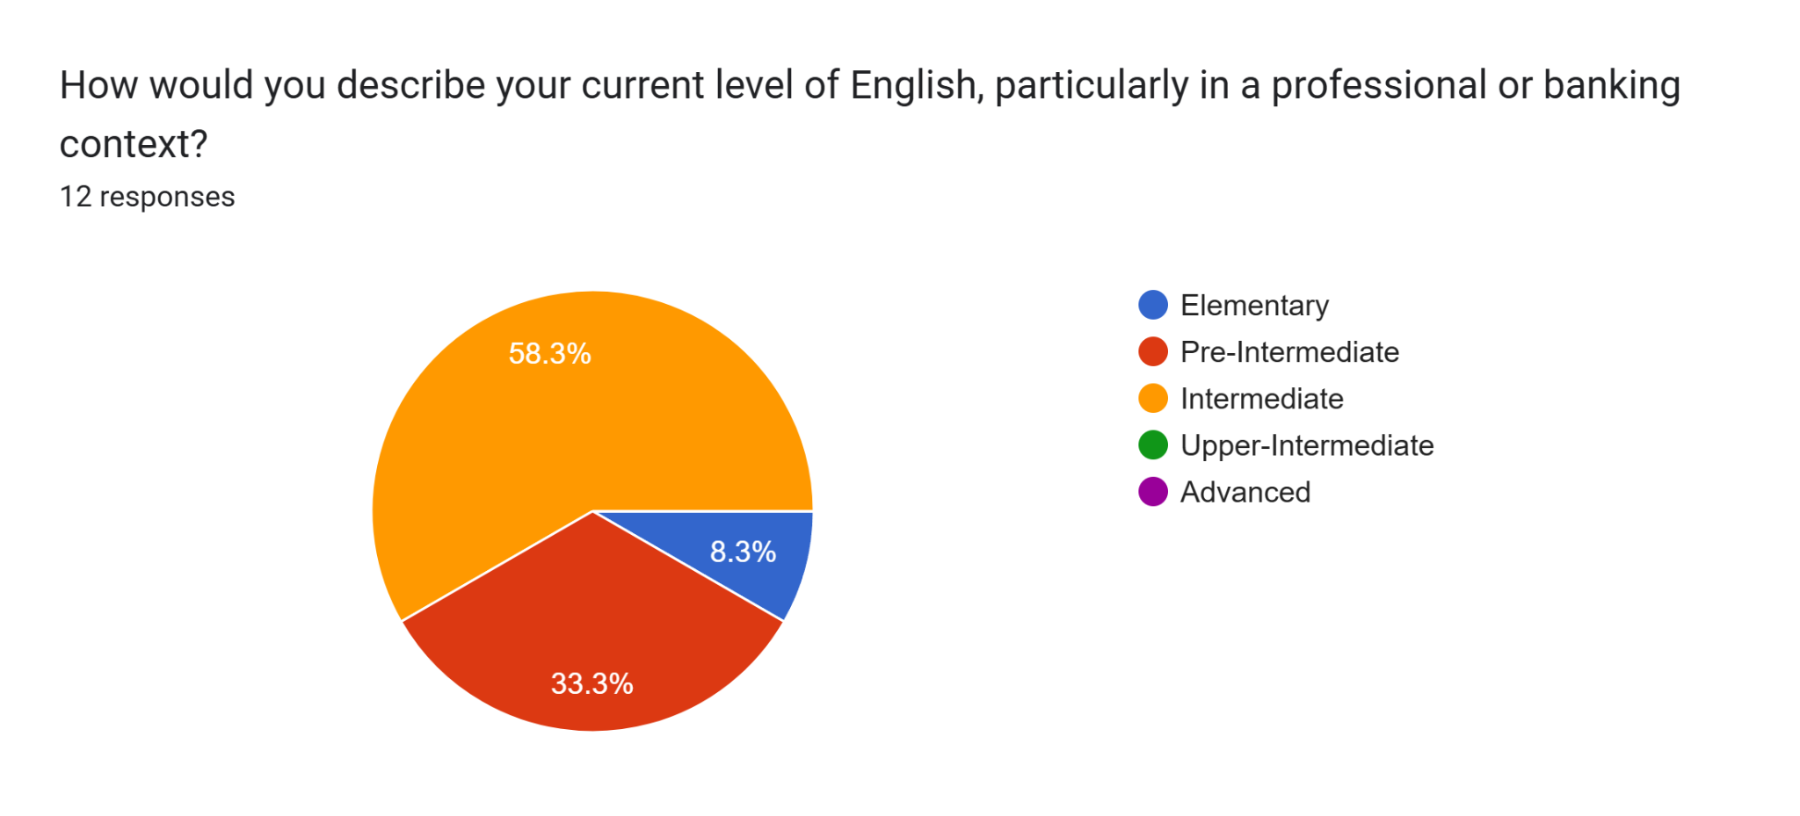

Top 3 English skills students prioritize:
General Speaking in daily situations, listening to understand, and Corporate/Professional English Speaking.
Key insight on top 3 selected English skills:
Since the percentages are so high for both General and Business English, the students aren't choosing one over the other—they are looking for a comprehensive program that covers both their social and professional lives.
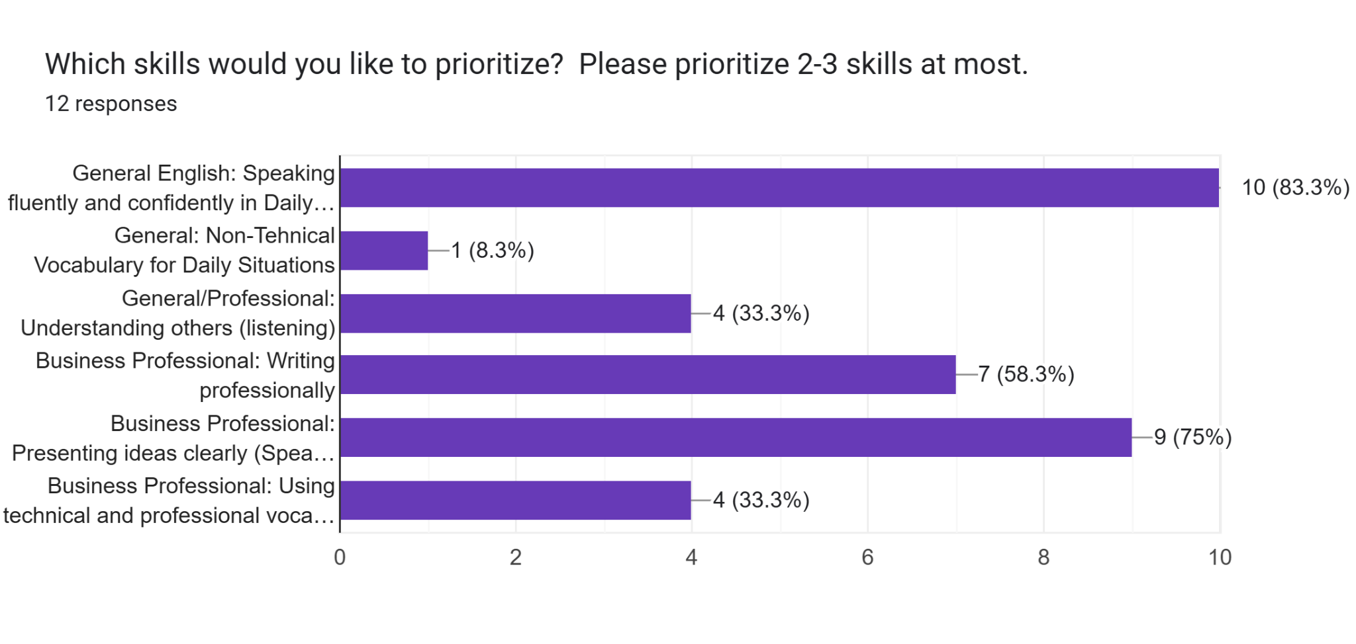

The Challenge:
Interestingly, both sides (90%>) wanted to study business English books. To satisfy the difficult request for both General English literature and business case studies, my proposed hybrid plan: we’ll use "The Book Thief" for our daily reading and dive into Harvard business articles every Friday to cover the business side.

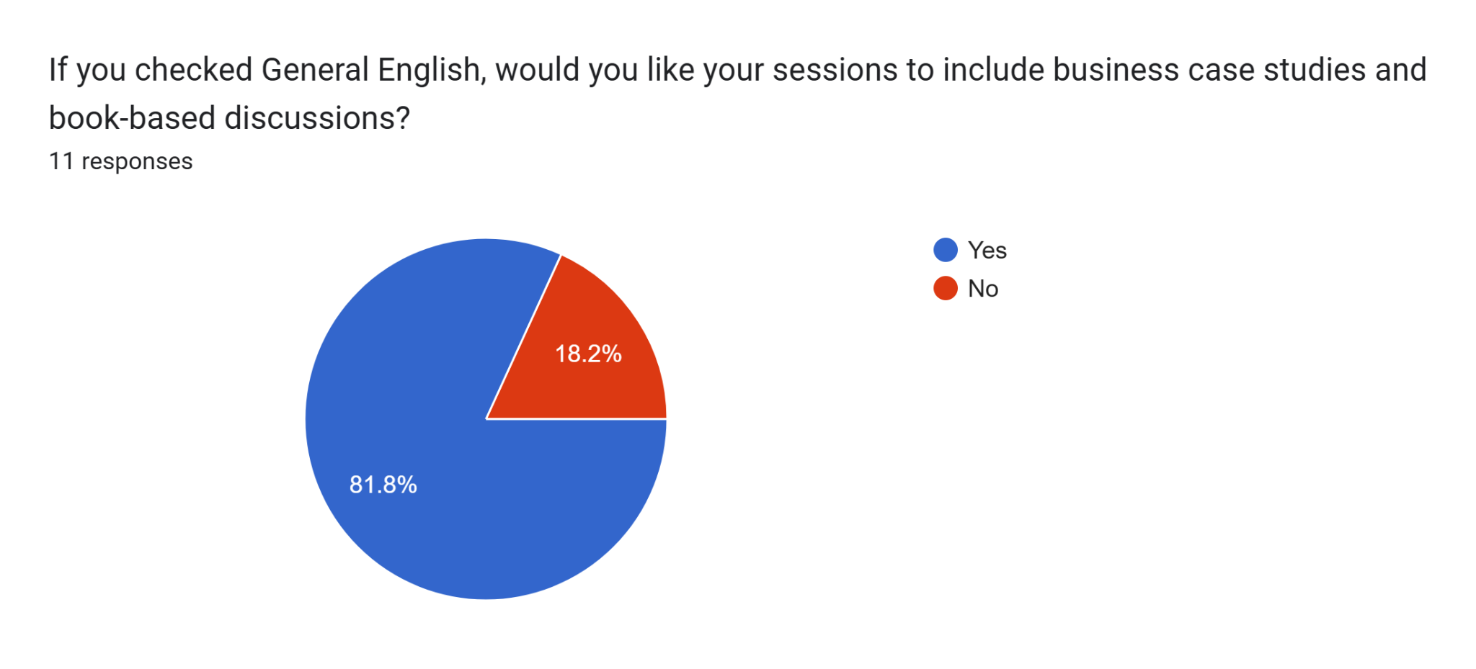
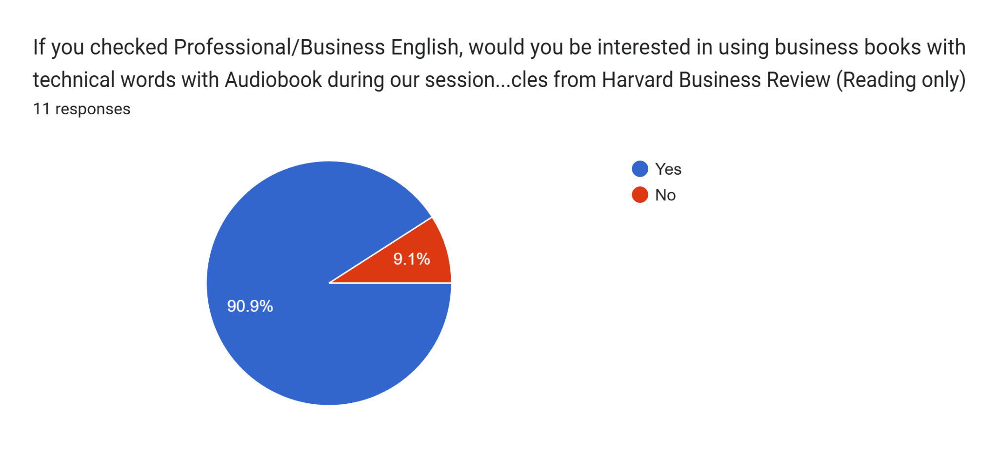

Proposed Solution:
Since the overlap is so high, our strategy is to use The Book Thief for General English four days a week and Good to Great for Business English once a week.

Class Structure: Monday, Tuesday, Wednesday, Thursday

Bimodal Input (40 min)
- Grammar based on the level 3 curriculum
- Listen to the audiobook while reading: Book Thief by Markus Zusak
Daily Goal: Listen and Read 3 pages a day.
Method: Each student will take turns to read one big paragraph and one group to finish reading 5 pages a day.

Output (40 min)
Style of Speaking for General English:
1. Daily conversation: talking about everyday life, routines, experiences
2. Small talk: casual conversation topics for social or work situations
3. Story-telling (sharing personal stories or experiences)

Buffer (10 min)

Strategy:
We will switch these 3 methods for our speaking sessions for General English in the Output part on Monday ~ Thursday. We will choose one method that had the best results more frequently than the other two methods for General Speaking on Monday ~ Thursday.
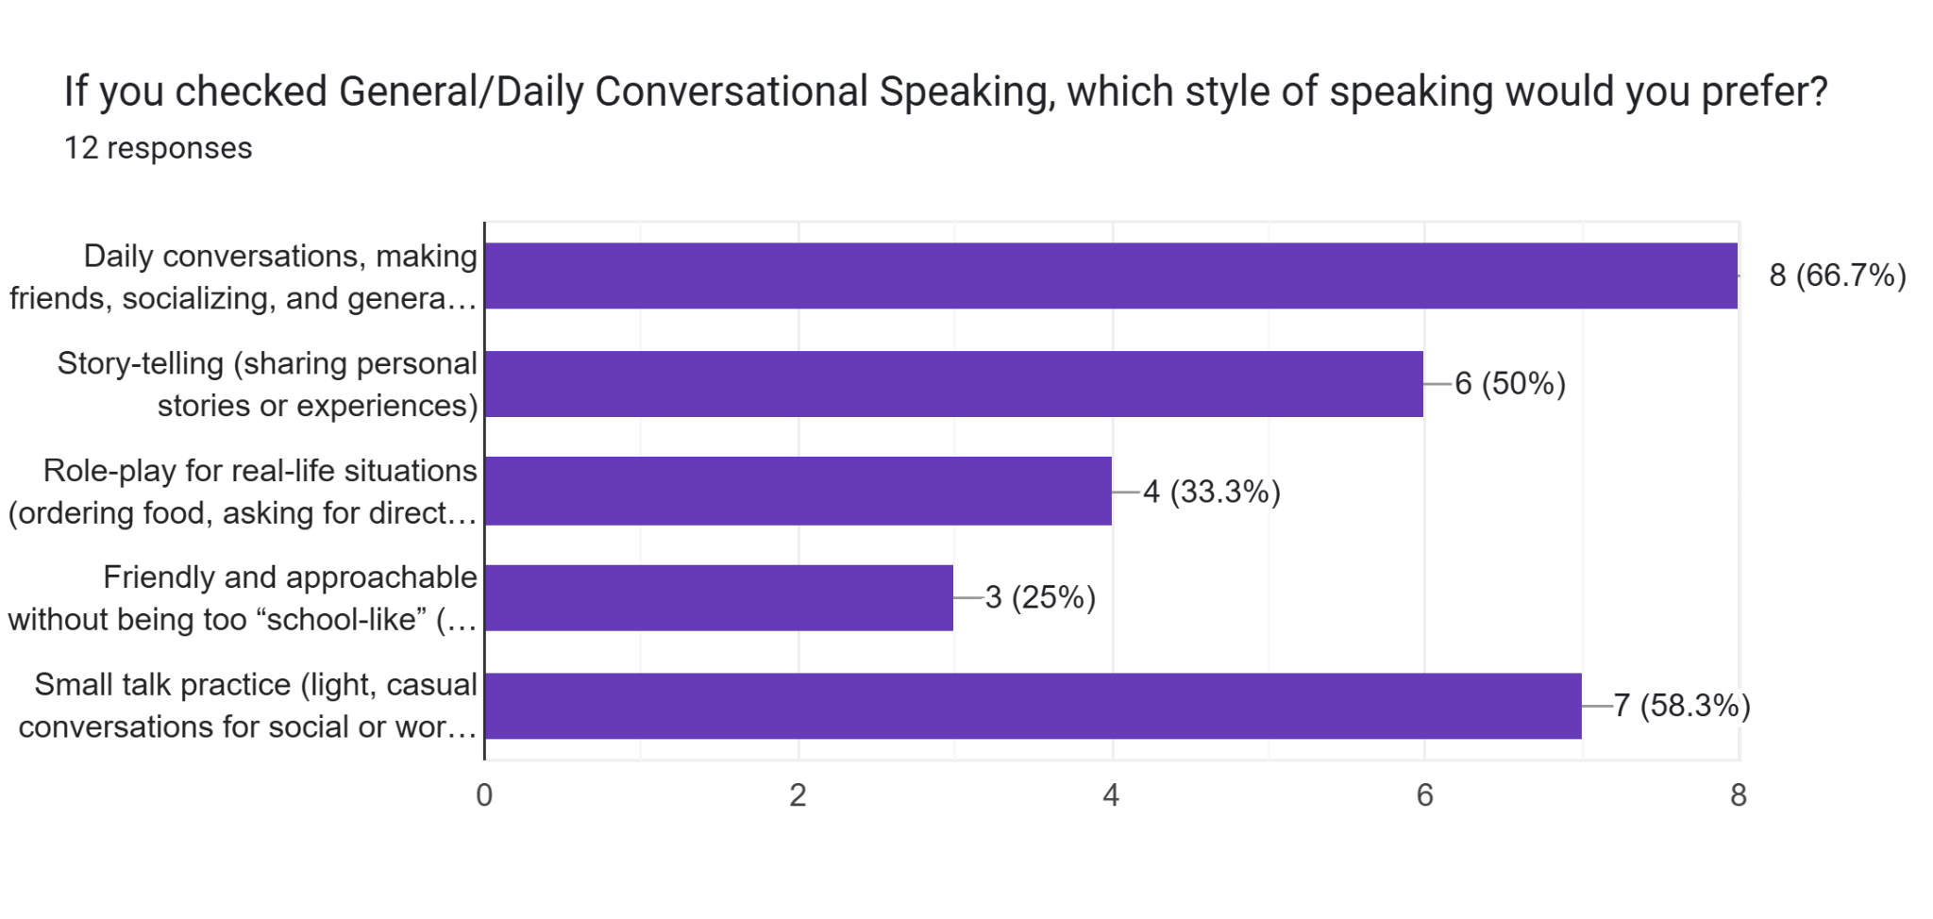

Class Structure: Friday

Bimodal Input (40 min)
- Grammar based on the Level 3 curriculum
- Reading: Good to Great by Jim Collins
Daily Goal: We read 3 ~ 5 pages per session.
Students take turns to read an entire paragraph. Highlight vocabularies they don’t know. After each student finishes reading the paragraph, shadowing technique for pronunciation correction, and the teacher will explain sentences and translate new business vocabularies.

Output (50 min)
Style of Speaking for Business English on Friday:
1. Opinion sharing (70%)
Goal: Encourage spontaneous speech, reasoning, and fluent expression.
“In your experience, what is more important in banking: client relationships or financial metrics?”
2. “What is the biggest challenge for a leader in the current market?”
3. “How do you personally stay effective and strategic under high-pressure situations?”

2. Case discussions (60%)
Examples:
Good to Great case: Walgreens vs Eckerd Discussion:
1. What specific decisions led to Walgreens’ success? Vocabulary focus: strategic growth, competitive advantage, core competencies.
2. Banking Case: Loan Risk Evaluation Scenario:
A client requests a high-value loan with limited collateral. Discussion: What factors would you consider before approval?
3. Leadership Case:
Crisis Management Scenario: A key client withdraws their investment.
Discussion: How should the bank respond to maintain trust and reputation?

3. Role-plays (50%)
Opinion Sharing
Goal: Encourage spontaneous speech, reasoning, and fluent expression.
1. “In your experience, what is more important in banking: client relationships or financial metrics?”
2. “What is the biggest challenge for a leader in the current market?”
3. “How do you personally stay effective and strategic under high-pressure situations?”

Strategy:
According to our survey, most students chose these 3 methods. We will switch these 3 speaking styles in the business English speaking session in the output part on Friday for Business English.
This will also provide insight and finding about which speaking style suits our Level 3 Business English the most.

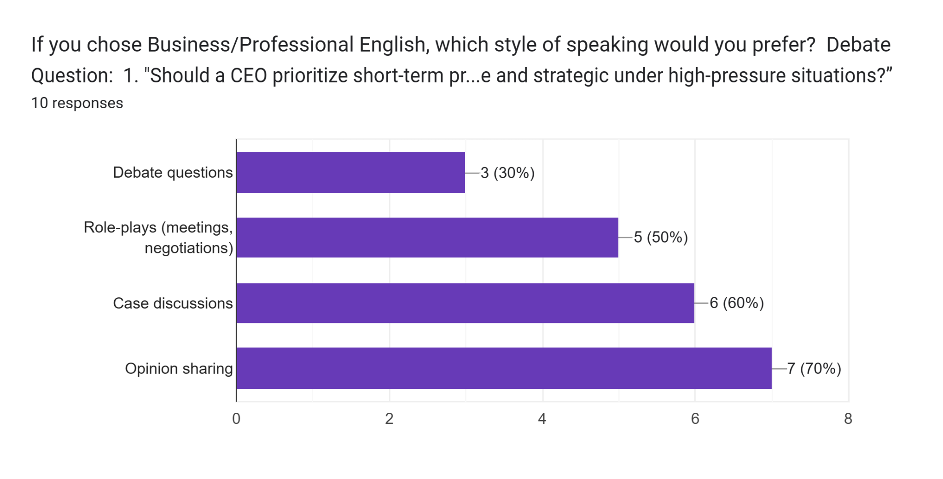

1-р сар: Нарийн цаг ба нөхцөлт байдлын сар

Зорилго: Level 2-д эзэмшсэн цагийн тогтолцоог Present Perfect Continuous болон Past Perfect-ээр баяжуулж, Third Conditional-ийг нэмснээр өнгөрсөн дэх боломж, харамсал, нөхцөл байдлыг бүрэн илэрхийлэх чадвартай болно.

1st month Week 1: Давталт ба Level 3 эхлэл / Review & Level 3 Launch
- Төвлөрөх сэдэв: Level 2-ын гол дүрмүүдийг (Present Perfect, Modals, Conditionals, Passive) шинэ контекстоор давтах.
- Дуудлага: Уян хатан дуудлага (stress shifting, weak forms, elision).

Өдөр | Сэдэв | Жишээ / Агуулга
Day 1 | Advanced Contractions  Good to Great Ch 1, Introduction | I would've / should've / could've / must've / might've  Reading Input (40 min)  Grammar based on the Level 3 curriculum  Reading: Good to Great by Jim Collins  Daily Goal: We read 3 ~ 5 pages per session.  Students take turns to read an entire paragraph. Highlight vocabularies they don’t know. After each student finishes reading the paragraph, shadowing technique for pronunciation correction, and the teacher will explain sentences and translate new business vocabularies.  Output (50 min)  Style of Speaking for Business English on Friday:  - Opinion sharing  - Case Discussions: Walgreens vs Eckerd  - Role-Play: Manager/Team leader, Team member A, Team member B
Day 2 | Nuanced Experience  Good to Great Ch 1, Phase 1 ~ 2 | I've been meaning to... / I'd been thinking about it…  Reading Input (40 min)  Grammar based on the Level 3 curriculum  Reading: Good to Great by Jim Collins  Daily Goal: We read 3 ~ 5 pages per session.  Students take turns to read an entire paragraph. Highlight vocabularies they don’t know. After each student finishes reading the paragraph, shadowing technique for pronunciation correction, and the teacher will explain sentences and translate new business vocabularies.  Output (50 min)  Style of Speaking for Business English on Friday:  - Opinion sharing  - Case Discussions: Walgreens vs Eckerd  - Role-Play: Manager/Team leader, Team member A, Team member B
Day 3 | Conditional Review  Audiobook, Good to Great Ch 1, Phase 3 ~ 4 | Mixing Zero, First, and Second Conditionals naturally.  Bimodal Input (40 min)  Grammar based on the Level 3 curriculum  Listening & Reading: Good to Great by Jim Collins  Daily Goal: We read 3 ~ 5 pages per session.  Students take turns to read an entire paragraph. Highlight vocabularies they don’t know. After each student finishes reading the paragraph, shadowing technique for pronunciation correction, and the teacher will explain sentences and translate new business vocabularies.  Output (50 min)  Style of Speaking for Business English on Friday:  - Opinion sharing  - Case Discussions: Walgreens vs Eckerd  - Role-Play: Manager/Team leader, Team member A, Team member B
Day 4  Mon | C1 Awareness  Good to Great, Ch 1 Book discussions | Goal setting: What does professional (C1) English sound like?  Podcast Input (10 min) for C1 awareness  Topic: The US Israeli war with Iran.  Source: https://www.oxfordenergy.org/publications  Output (80 min)  Style of Speaking for Business English on Friday:  - Opinion sharing  - Case Discussions: Walgreens vs Eckerd  - Role-Play: Manager/Team leader, Team member A, Team member B
Day 5  Tue | Weekly Review | Өмнө нь үзсэн зүйлсээ бататгах  - Fill-in the blank exercises on Grammar.  - Finish the vocabulary with correct letters in the place.  - Match vocabulary with synonyms.  - Read a small paragraph and answer questions.  - Answer one thesis questions from Good To Great Chapter 1, using the structure, useful phrases, and linking words provided in the exam.

Week 2: Одоо төгссөн үргэлжлэх цаг / Present Perfect Continuous
- Төвлөрөх сэдэв: Үйл хөдлөл одоог хүртэл үргэлжилж байгаа болон үр нөлөө үлдсэнийг илэрхийлэх.
- Анхаарах: Simple vs. Continuous ялгаа болон "For / Since" хэрэглээ.
Өдөр | Сэдэв | Жишээ / Агуулга
Day 1  Wed | Core Structure  Audiobook: Book Thief by Markus Zusak | I've been working all morning. / She's been studying.  Bimodal Input (40 min)  - Listen to the audiobook while reading: Book Thief by Markus Zusak  Daily Goal: Listen and Read 3 pages a day.  Method: Each student will take turns to read one big paragraph and one group to finish reading 3 pages a day.  Output (40 min)  Style of Speaking for General English: Tie the topic from one title of the Book Thief.  1. Daily conversation: talking about everyday life, routines, experiences  2. Small talk: casual conversation topics for social or work situations  3. Story-telling (sharing personal stories or experiences)
Day 2  Thu | Simple vs. Continuous  Audiobook: Book Thief by Markus Zusak | I've read 3 chapters (finished) vs. I've been reading (process).  Bimodal Input (40 min)  Listen to the audiobook while reading: Book Thief by Markus Zusak  Daily Goal: Listen and Read 3 pages a day.  Method: Each student will take turns to read one big paragraph and one group to finish reading 3 pages a day.  Output (40 min)  Style of Speaking for General English: Tie the topic from one title of the Book Thief.  1. Daily conversation: talking about everyday life, routines, experiences  2. Small talk: casual conversation topics for social or work situations  3. Story-telling (sharing personal stories or experiences)
Day 3  Fri | For & Since Deepening  Good to Great, Ch 2 | How long have you been...? / Since I graduated / For a week.  Reading Input (40 min)  Grammar based on the Level 3 curriculum  Reading: Good to Great by Jim Collins  Daily Goal: We read 3 ~ 5 pages per session.  Students take turns to read an entire paragraph. Highlight vocabularies they don’t know. After each student finishes reading the paragraph, shadowing technique for pronunciation correction, and the teacher will explain sentences and translate new business vocabularies.  Output (50 min)  Style of Speaking for Business English on Friday:  - Opinion sharing  - Case Discussions: Walgreens vs Eckerd  - Role-Play: Manager/Team leader, Team member A, Team member B
Day 4  Mon | Evidence-based Output  Audiobook: Book Thief by Markus Zusak | Look at these signs — What has someone been doing?  Bimodal Input (40 min)  Listen to the audiobook while reading: Book Thief by Markus Zusak  Daily Goal: Listen and Read 3 pages a day.  Method: Each student will take turns to read one big paragraph and one group to finish reading 3 pages a day.  Output (40 min)  Style of Speaking for General English: Tie the topic from one title of the Book Thief.  1. Daily conversation: talking about everyday life, routines, experiences  2. Small talk: casual conversation topics for social or work situations  3. Story-telling (sharing personal stories or experiences)
Day 5  Tue | Weekly Review | Өмнө нь үзсэн зүйлсээ бататгах

Week 3: Өнгөрсөн төгссөн цаг / Past Perfect
- Төвлөрөх сэдэв: Өнгөрсөн дэх хоёр үйл явдлын дарааллыг ялгах (The "earlier past").
- Холбоос үгс: By the time, when, after, before.
Өдөр | Сэдэв | Жишээ / Агуулга
Day 1  Wed | Core Structure  Audiobook: Book Thief by Markus Zusak | When I arrived, she had already left. / He had never seen snow.  Bimodal Input (40 min)  Listen to the audiobook while reading: Book Thief by Markus Zusak  Daily Goal: Listen and Read 3 pages a day.  Method: Each student will take turns to read one big paragraph and one group to finish reading 3 pages a day.  Output (40 min)  Style of Speaking for General English: Tie the topic from one title of the Book Thief.  1. Daily conversation: talking about everyday life, routines, experiences  2. Small talk: casual conversation topics for social or work situations  3. Story-telling (sharing personal stories or experiences)
Day 2  Fri | Sequencing  Good to Great, Ch 2 | By the time she called, I had already decided  Reading Input (40 min)  Grammar based on the Level 3 curriculum  Reading: Good to Great by Jim Collins  Daily Goal: We read 3 ~ 5 pages per session.  Students take turns to read an entire paragraph. Highlight vocabularies they don’t know. After each student finishes reading the paragraph, shadowing technique for pronunciation correction, and the teacher will explain sentences and translate new business vocabularies.  Output (50 min)  Style of Speaking for Business English on Friday:  - Opinion sharing  - Case Discussions: Walgreens vs Eckerd  - Role-Play: Manager/Team leader, Team member A, Team member B
Day 3  Mon | Combining Past Tenses  Audiobook: Book Thief by Markus Zusak | Storytelling: Simple Past + Continuous + Past Perfect.  Bimodal Input (40 min)  Listen to the audiobook while reading: Book Thief by Markus Zusak  Daily Goal: Listen and Read 3 pages a day.  Method: Each student will take turns to read one big paragraph and one group to finish reading 3 pages a day.  Output (40 min)  Style of Speaking for General English: Tie the topic from one title of the Book Thief.  1. Daily conversation: talking about everyday life, routines, experiences  2. Small talk: casual conversation topics for social or work situations  3. Story-telling (sharing personal stories or experiences)
Day 4  Tue | Story Narration  Audiobook: Book Thief by Markus Zusak | Dramatic story output (3+ minutes speech).  Bimodal Input (40 min)  Listen to the audiobook while reading: Book Thief by Markus Zusak  Daily Goal: Listen and Read 3 pages a day.  Method: Each student will take turns to read one big paragraph and one group to finish reading 3 pages a day.  Output (40 min)  Style of Speaking for General English: Tie the topic from one title of the Book Thief.  1. Daily conversation: talking about everyday life, routines, experiences  2. Small talk: casual conversation topics for social or work situations  3. Story-telling (sharing personal stories or experiences)
Day 5  Wed | Weekly Review | Өмнө нь үзсэн зүйлсээ бататгах

Week 4: Гурав дахь нөхцөлт ба холимог нөхцөлт / Third & Mixed Conditionals
- Төвлөрөх сэдэв: Өнгөрсөн дэх харамсал илэрхийлэх (B1 -> B2 шилжилт).
- Mixed Conditional: Өнгөрсөн нөхцөл байдал одоод хэрхэн нөлөөлж байгааг тайлбарлах.
Өдөр | Сэдэв | Жишээ / Агуулга
Day 1  Thu | Third Conditional  Audiobook: Book Thief by Markus Zusak | If I had studied harder, I would have passed.  Bimodal Input (40 min)  Listen to the audiobook while reading: Book Thief by Markus Zusak  Daily Goal: Listen and Read 3 pages a day.  Method: Each student will take turns to read one big paragraph and one group to finish reading 3 pages a day.  Output (40 min)  Style of Speaking for General English: Tie the topic from one title of the Book Thief.  1. Daily conversation: talking about everyday life, routines, experiences  2. Small talk: casual conversation topics for social or work situations  3. Story-telling (sharing personal stories or experiences)
Day 2  Fri | Regret & Criticism  Good to Great, Ch 2 | I wish I had listened. / You should have told me.  Reading Input (40 min)  Grammar based on the Level 3 curriculum  Reading: Good to Great by Jim Collins  Daily Goal: We read 3 ~ 5 pages per session.  Students take turns to read an entire paragraph. Highlight vocabularies they don’t know. After each student finishes reading the paragraph, shadowing technique for pronunciation correction, and the teacher will explain sentences and translate new business vocabularies.  Output (50 min)  Style of Speaking for Business English on Friday:  - Opinion sharing  - Case Discussions: Walgreens vs Eckerd  - Role-Play: Manager/Team leader, Team member A, Team member B
Day 3  Mon | Mixed Conditionals  Audiobook: Book Thief by Markus Zusak | If I had studied medicine (past), I would be a doctor (now).  Bimodal Input (40 min)  Listen to the audiobook while reading: Book Thief by Markus Zusak  Daily Goal: Listen and Read 3 pages a day.  Method: Each student will take turns to read one big paragraph and one group to finish reading 3 pages a day.  Output (40 min)  Style of Speaking for General English: Tie the topic from one title of the Book Thief.  1. Daily conversation: talking about everyday life, routines, experiences  2. Small talk: casual conversation topics for social or work situations  3. Story-telling (sharing personal stories or experiences)
Day 4  Tue | Life Turning Points  Audiobook: Book Thief by Markus Zusak | Turning points: What would be different if things had changed?  Bimodal Input (40 min)  Listen to the audiobook while reading: Book Thief by Markus Zusak  Daily Goal: Listen and Read 3 pages a day.  Method: Each student will take turns to read one big paragraph and one group to finish reading 3 pages a day.  Output (40 min)  Style of Speaking for General English: Tie the topic from one title of the Book Thief.  1. Daily conversation: talking about everyday life, routines, experiences  2. Small talk: casual conversation topics for social or work situations  3. Story-telling (sharing personal stories or experiences)
Day 5  Thu | Weekly Review | Өмнө нь үзсэн зүйлсээ бататгах

